XXX风险分析报告

拟制
审核
批准
日期

修订历史
版本 | 日期 | 作者 | 审核 | 文档状态 | 修改内容
注：文档状态：“草稿“，”已审核“，”已发布“

Contents
1 目的 3
2 参考文档 4
3 危险识别 4
4 风险分析 4
5 安全目标 8

- 目的
风险分析是通过对产品在使用过程中的失效和失效带来的对环境、人身造成的危害进行分析，识别出产品的潜在风险，并制定相应的应对措施。
- 参考文档
文档名称 | 版本
ISO 13849-1 | 2023

- 危险识别
危险源 | 电芯过欠压
 | 电芯充放电过流
 | 电芯温度过高过低

- 风险分析
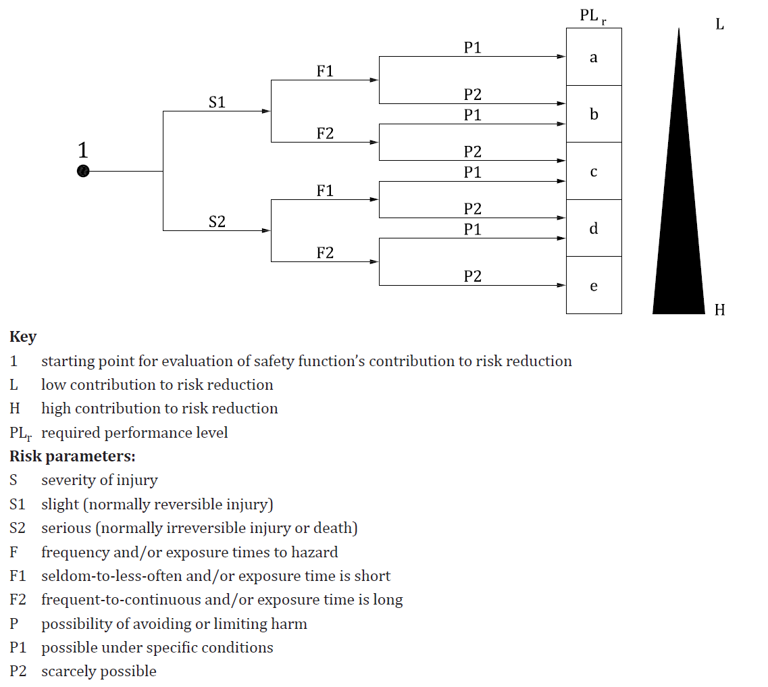
电芯过欠压
S | F | P
S2 | F1 | P1
由于过压导致爆炸起火容易造成人身伤害 | 人员暴露于爆炸环境的几率小 | 可以通过预防减小伤害

ITEM | C | B | A
use of the machine by | ☐ | ☐ | ☒
speed of the part of the  machine that can create a hazardous event (depending on the specific machine and time to escape from orto avoid a hazardous situation) | ☐ | ☐ | ☒
spatial possibility to  escape from the hazard | ☐ | ☐ | ☒
possibility of recognition/  awareness of the  hazard(e.g. hot/cold surface,non-ionising radiation etc.) | ☐ | ☒ | ☐
complexity of the operations(human interaction in terms of numbers of operation and/or timing available for this operations) | ☐ | ☐ | ☒
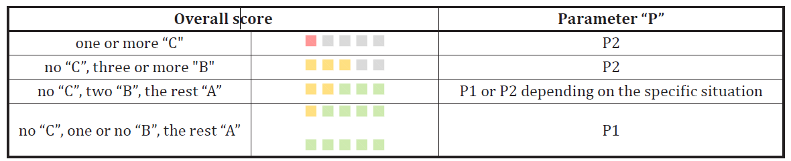
电芯过流
S | F | P
S2 | F1 | P1
由于过流导致爆炸起火容易造成人身伤害 | 人员暴露于爆炸环境的几率小 | 可以通过预防减小伤害

ITEM | C | B | A
use of the machine by | ☐ | ☐ | ☒
speed of the part of the  machine that can create a hazardous event (depending on the specific machine and time to escape from orto avoid a hazardous situation) | ☐ | ☐ | ☒
spatial possibility to  escape from the hazard | ☐ | ☐ | ☒
possibility of recognition/  awareness of the  hazard(e.g. hot/cold surface,non-ionising radiation etc.) | ☐ | ☒ | ☐
complexity of the operations(human interaction in terms of numbers of operation and/or timing available for this operations) | ☐ | ☐ | ☒

电芯高低温
S | F | P
S2 | F1 | P1
由于温度导致爆炸起火容易造成人身伤害 | 人员暴露于爆炸环境的几率小 | 可以通过预防减小伤害

ITEM | C | B | A
use of the machine by | ☐ | ☐ | ☒
speed of the part of the  machine that can create a hazardous event (depending on the specific machine and time to escape from orto avoid a hazardous situation) | ☐ | ☐ | ☒
spatial possibility to  escape from the hazard | ☐ | ☐ | ☒
possibility of recognition/  awareness of the  hazard(e.g. hot/cold surface,non-ionising radiation etc.) | ☐ | ☒ | ☐
complexity of the operations(human interaction in terms of numbers of operation and/or timing available for this operations) | ☐ | ☐ | ☒

- 安全目标
安全目标1
描述：
保护阈值：
响应事件：
安全状态：
列出所有的安全目标

